Contrac Corporate Colours

Grey: R 118 G 119 B 122 / C 53 M 42 Y 39 K 23
Pink: R 226 G 14 B 131 / C 4 M 96 Y 0 K 0
Blue: R 0 G 159 B 226 / C 75 M 21 Y 0 K 0



Blue:
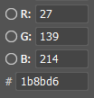

Purple:
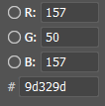

Pink:
